CMSC203 Assignment 1 Implementation (Documentation)

Class: CMSC203 CRN 21352
Program: Assignment #1
Instructor: Khandan Monshi
Summary of Description: (Give a brief description for each Program)
Due Date: 09/15/2026
Integrity Pledge: I pledge that I have completed the programming assignment independently.
I have not copied the code from a student or any source.
Student Name: Raghav Ghorakavi

Part1: Pseudo Code: Here is a pseudo code for the Assignment 1 program:

START MAIN ALGORITHM

// --- SECTION 1: VARIABLE INITIALIZATION & DEFAULT WEIGHTS ---
Set default weights: projects = 0.4, quizzes = 0.3, exams = 0.3
Set default course = "CMSC 203: Computer Science I"

// --- SECTION 2: PROCESS CONFIGURATION FILE ---
IF configuration file "gradeconfig.txt" exists THEN
Display "Loading gradeconfig.txt..."
Open "gradeconfig.txt" for reading
Read first line and assign to course
Skip the second line of the file

Repeat 3 times:
Read next category label from file
IF category is "PROJECTS" (case-insensitive) THEN
Read value from file, divide by 100, and assign to projects
ELSE IF category is "QUIZZES" (case-insensitive) THEN
Read value from file, divide by 100, and assign to quizzes
ELSE IF category is "EXAMS" (case-insensitive) THEN
Read value from file, divide by 100, and assign to exams
ELSE
Display "Malformed gradeconfig.txt. Reverting to defaults."
Reset weights: projects = 0.4, quizzes = 0.3, exams = 0.3
Close configuration file
Exit the loop early
END IF
End Repeat

IF (projects + quizzes + exams) is not equal to 1.0 THEN
Display "Weights do not add to 100. Reverting to defaults."
Reset weights: projects = 0.4, quizzes = 0.3, exams = 0.3
ELSE
Display "Config loaded successfully."
END IF
Close configuration file
ELSE
Display "Missing gradeconfig.txt. Using defaults."
END IF

// --- SECTION 3: USER INPUT & VALIDATION ---
Display "Enable +/- grading? (Y/N)"
Read selection string from user keyboard

// Input validation loop
WHILE selection is not "Y" and selection is not "N" (case-insensitive) DO
Display "Use N/n for no and Y/y for yes. Please do not use anything else."
Read selection string from user keyboard
END WHILE

// Set grading flag based on user selection
IF selection is "N" (case-insensitive) THEN
Set plus_minus_flag = FALSE
ELSE
Set plus_minus_flag = TRUE
END IF

// --- SECTION 4: PROCESS STUDENT GRADES FILE ---
Set grand_sum = 0

IF input file "grades_input.txt" exists THEN
Open "grades_input.txt" for reading
Read first line from file and assign to first_name
Read second line from file and assign to last_name

Display "Scanning grades_input.txt..."
Display "Student: " + first_name + " " + last_name
Display "Course: " + course

// Loop through the 3 grade categories
Repeat 3 times:
Set category_sum = 0
Read next line from file and assign to category_name
Read next integer from file and assign to score_count

// Nested loop to sum up individual scores
Repeat score_count times:
Read next number from file and add it to category_sum
End Repeat

Calculate category_average = category_sum / score_count

IF category_name is "PROJECTS" (case-insensitive) THEN
Display "Projects: " + category_average
Add (category_average * projects) to grand_sum
ELSE IF category_name is "QUIZZES" (case-insensitive) THEN
Display "Quizzes: " + category_average
Add (category_average * quizzes) to grand_sum
ELSE IF category_name is "EXAMS" (case-insensitive) THEN
Display "Exams: " + category_average
Add (category_average * exams) to grand_sum
ELSE
Display "Malformed grades_input.txt. Try again later."
Terminate the program completely
END IF

Skip remaining character spaces or newline markers in the category section
End Repeat
Close grades file
ELSE
Display "Missing grades_input.txt. Make sure the file is in the folder."
Terminate the program completely
END IF

// --- SECTION 5: FINAL SCORE & LETTER GRADE LOGIC ---
Set overall_average = grand_sum
Display "Overall average: " + overall_average

IF overall_average >= 97 AND plus_minus_flag is TRUE THEN
Display "Final letter grade: A+"
ELSE IF (overall_average >= 93 AND plus_minus_flag is TRUE) OR (overall_average >= 90 AND plus_minus_flag is FALSE) THEN
Display "Final letter grade: A"
ELSE IF overall_average >= 90 AND plus_minus_flag is TRUE THEN
Display "Final letter grade: A-"
ELSE IF overall_average >= 87 AND plus_minus_flag is TRUE THEN
Display "Final letter grade: B+"
ELSE IF (overall_average >= 83 AND plus_minus_flag is TRUE) OR (overall_average >= 80 AND plus_minus_flag is FALSE) THEN
Display "Final letter grade: B"
ELSE IF overall_average >= 80 AND plus_minus_flag is TRUE THEN
Display "Final letter grade: B-"
ELSE IF overall_average >= 77 AND plus_minus_flag is TRUE THEN
Display "Final letter grade: C+"
ELSE IF (overall_average >= 73 AND plus_minus_flag is TRUE) OR (overall_average >= 70 AND plus_minus_flag is FALSE) THEN
Display "Final letter grade: C"
ELSE IF overall_average >= 70 AND plus_minus_flag is TRUE THEN
Display "Final letter grade: C-"
ELSE IF overall_average >= 67 AND plus_minus_flag is TRUE THEN
Display "Final letter grade: D+"
ELSE IF (overall_average >= 63 AND plus_minus_flag is TRUE) OR (overall_average >= 60 AND plus_minus_flag is FALSE) THEN
Display "Final letter grade: D"
ELSE IF overall_average >= 60 AND plus_minus_flag is TRUE THEN
Display "Final letter grade: D-"
ELSE
Display "Final letter grade: F"
END IF

END MAIN ALGORITHM

Part2: Comprehensive Test Plan
A good test plan should be comprehensive. This means you should have a few test cases that test when the input is in and out of range, division by 0, incorrect Data type, etc. (Provide valid and invalid input)
Cases | Input | Expected Output | Actual Output | Did the test pass?
Case 1 | Grade weights do not add to 100 | “Weights do not add to 100. Reverting to defaults.” And switches to default 30/30/40 | “Weights do not add to 100. Reverting to defaults.” Successfully switched. | YES
Case 2 | Change the title of a category to an invalid name | "Malformed gradeconfig.txt. Reverting to defaults." | "Malformed gradeconfig.txt. Reverting to defaults." | YES
Case 3 | Use a letter (not y/n) for +/- grading prompt | Rejects user and asks them to try again | “Use N/n for no and Y/y for yes. Please do not use anything else.” Repeats user in | YES
Case 4 | File missing | Reverts to defaults if gradeconfig, exits gracefully if grade_input. | “Missing gradeconfig.txt. Using defaults. File should be stored in C:\Users\-----\eclipse-workspace\assignment1\gradeconfig.txt  Missing grades_input.txt. Make sure the file is stored in C:\Users\-----\eclipse-workspace\assignment1\grades_input.txt

Part3: Screenshots related to the Test Plan:

Case 1
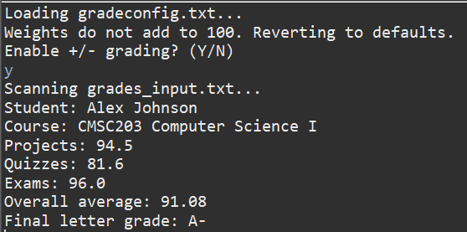
Case 2
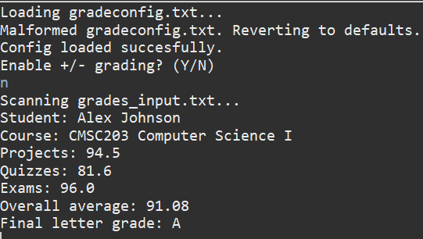
Case 3
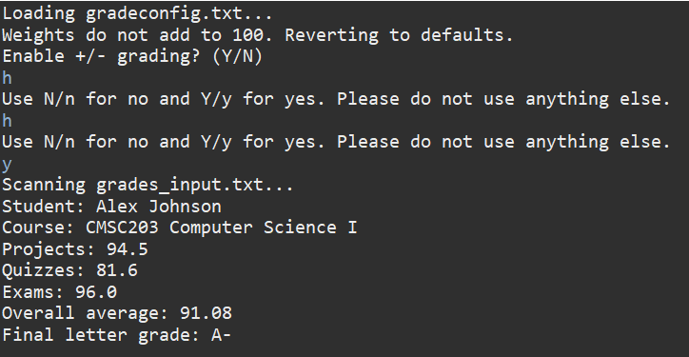

Case 4

Lessons Learned <Provide answers to the questions listed above>:

Write about your Learning Experience, highlighting your lessons learned and learning experience from working on this project.

What have you learned?
I learned how to deal with errors concerning file paths. I also learned how to use Scanner objects to scan .txt files and stacking if-else statements and for-loops.

What did you struggle with?
I struggled with dealing with errors, which caused me to dig into the File class’s documentation to find operators that would help me (such as .exists()).

What would you do differently on your next project?
In this project, I wrote all the code in one go and then tested. In future projects, I will test as I go. This will make debugging much easier.

What parts of this assignment were you successful with, and what parts (if any) were you not successful with?
I was successful with almost everything in this assignment.

Provide any additional resources/links/videos you used to while working on this assignment/project.

Check List: <Provide answers to the column Y/N or N/A >:

# |  | Y/N | Comments
 | Assignment files:
 | - FirstInitialLastName_ Assignment1_JavaFiles.zip | Y
 | - FirstInitialLastName_Assignment1_Complete.zip | Y
 | - Source Java files  - Documentation_File.docx | Y
 | Program compiles | Y
 | The program runs with the desired outputs related to a Test Plan | Y
 | Documentation file: | Y
 | - Comprehensive Test Plan | Y
 | - Screenshots related to the Test Plan | Y
 | - Screenshots of your GitHub account with submitted Assignment# (if required) | N/A
 | - Pseudocode | Y
 | - Lessons Learned | Y
 | - Checklist is completed and included in the Documentation | Y

